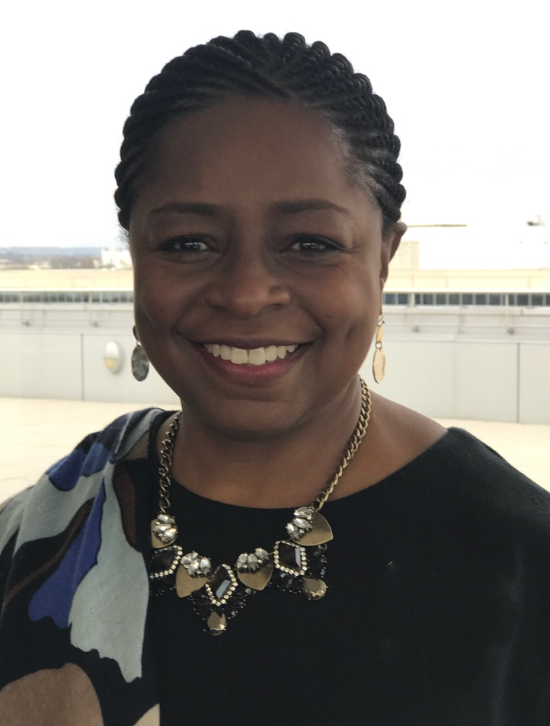

Angela Guy is the Senior Vice President, Diversity and Inclusion for L’Oréal USA, the largest subsidiary of the L’Oréal Group, the world’s leading beauty company. Ms. Guy is responsible for shaping the diversity efforts for L’Oréal USA as a business imperative that highlights the value of all forms of beauty while respecting and reflecting the differences of our rapidly changing marketplace. She is a member of the L’Oréal USA Strategic, Executive and Benefits Committees and collaborates to align L’Oréal’s global diversity efforts. Ms. Guy reports directly to Frédéric Rozé, President and CEO, L’Oréal USA.
Prior to this appointment, Ms. Guy was Senior Vice President, General Manager of SoftSheen-Carson, a Consumer Division of L’Oréal USA. In this role, Ms. Guy oversaw all aspects of the SoftSheen-Carson brand P&L in the U.S., Canada and the Caribbean. Ms. Guy also worked 19 years at Johnson & Johnson throughout the USA and Canada; 3 years in Sales with Levi Strauss & Company, Accessories Division and 3 years in Retail Operations Management with Hills Department Stores.

She is Board Co-Chair of the American Conference on Diversity; former Board Member for Harvest of Hope Family Services Network, Inc., Advisory Board and member of the Coalition of 100 Black Women, NYC; Steering Committee Member of Employers for Pay Equity, member of Delta Sigma Theta Sorority, Inc., NAACP, Pennsylvania State University Alumni and Executive Leadership Council.

Ms. Guy has been recognized as: one of the 2017 Ebony Magazine Power 100, Diversity Global Magazine’s “Top 10 Champions of Global Diversity;” Savoy Magazine’s “100 Most Influential Blacks in Corporate America” and “Top Influential Women in Corporate America”; a Black Enterprise “Power Player,” and “75 Most Powerful Women in Business”; one of “The 25 Influential Black Women in Business" by The Network Journal; a Beacon Corporate Leadership Award Recipient by the Coalition of 100 Black Women, and a host of other achievements.

Ms. Guy has a B.A. in Psychology from Pennsylvania State University, and attended Management Development Programs at UCLA, Northwestern University, the Center for Creative Leadership and the Harvard Kennedy School.

